Report

Date | 26 June 2025
Team ID | PNT2022TMIDxxxxxx
Project Name | Title
Maximum Marks | 5 Marks

A report is a structured document that explains the data analysis, visualizations, and key findings. In this project, Power BI was used to visualize a Kaggle dataset related to global food production. The goal was to help users easily understand food trends using charts and filters. The report is useful for policymakers, analysts, and students who want to explore food production across countries and crops.
In Power BI, the dataset was imported directly without coding or preprocessing. Charts like column charts, card, ribbon chart, donut chart, gauge, area chart, and funnel chart were used. These visuals were organized clearly, and slicers were added to allow filtering by year, country, and crop. The report was designed to be interactive and simple to use.
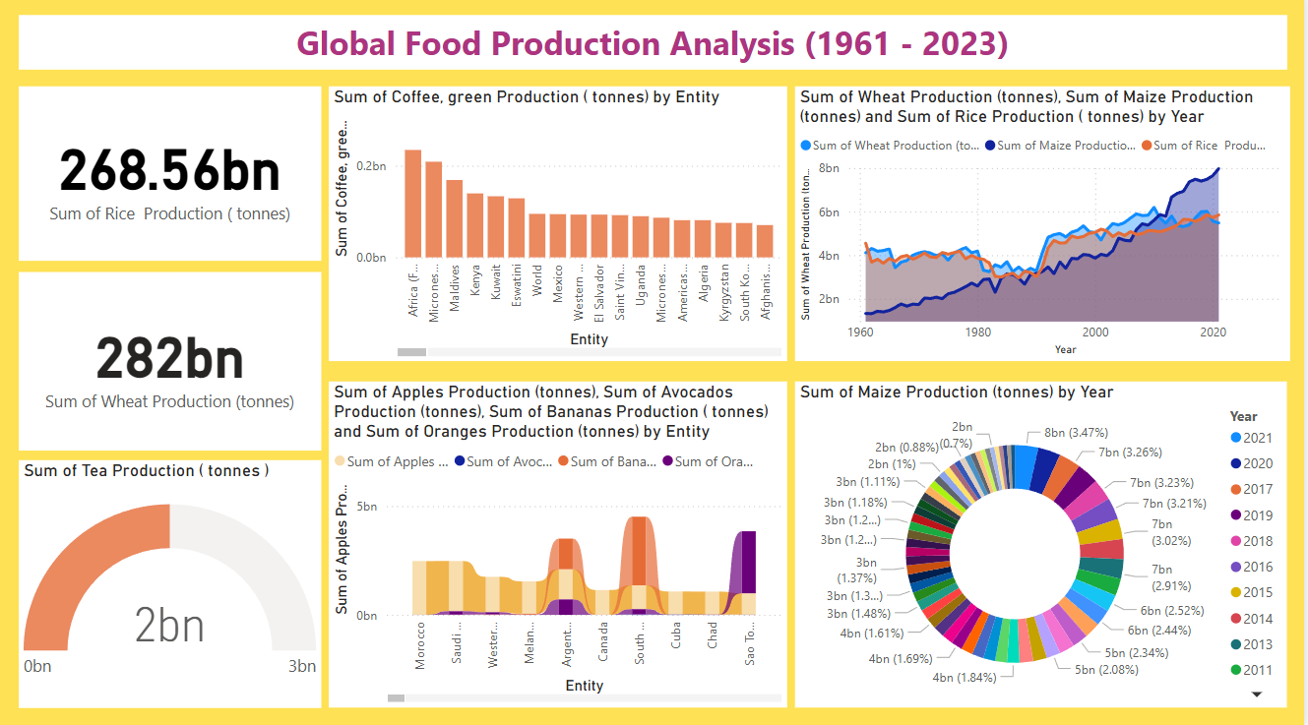

Observations drawn from reports in Power BI can provide valuable insights into business performance and trends.
- Trends Over Time:
• The area and line charts show how food production has changed from 1961 to 2020. Crops like wheat and rice showed steady growth until 2015, followed by a slight dip. This trend helps identify production peaks and possible seasonal patterns.
- Performance Comparisons:
• The column and ribbon charts allow comparison between countries. India and China have remained top producers of rice and wheat, while some African nations showed lower production levels. This helps identify both leading and underperforming regions.
- Category Share (Crop Segmentation):
• The donut chart shows crop-wise distribution. Rice, wheat, and maize account for the majority of global production. This segmentation helps focus policies and research on the most impactful crops.
- Goal Achievement:
• The gauge chart shows that global food production is close to or exceeding the expected threshold. It indicates that key food security goals are being met in many regions.
Example:
- Top Producer Country:
• The card visual shows that India is the highest producer in the dataset, especially in rice and wheat production.
- Crop Contribution:
• The donut chart highlights that rice holds the largest share in global food production, followed by wheat and maize.
- Production by Year:
• The area chart shows increasing trends in crop output from 1961–2023, with stability or slight decrease afterward. This helps plan for future yield management.
- Filtering with Funnel:
• The funnel chart filters data from total production → region → country → specific crop. This allows focused analysis at each level..

